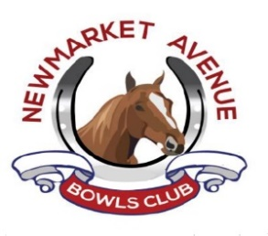
22 The Avenue, Newmarket CB89AY
NABC1936@outlook.com
Date March 2024
Dear Recipient,
2024 Club Competitions will take on the following format.
Men’s Singles 21 Shots – First Round Play by date – Following dates advised via WEB and Notice board.
Ladies Singles 21 Shots – First Round Play by date – Following dates advised via WEB and Notice board.
Mixed Singles 21 Shots – First Round Play by date – Following dates advised via WEB and Notice board.
Mixed Pairs 18 Ends – First Round Play by date – Following dates advised via WEB and Notice board.
Aussie Pairs (open to members and non-Members) 18 Ends -Pairs to arrange their own games.
Kind regards,

Lloyd Southgate Club Competitions
Newmarket Avenue Bowls Club Committee member
NABC1936@outlook.com

